

**Term End Examination 2013-14**

**M.TECH.,**

**Course: MAT513– MATHEMATICAL FOUNDATIONS OF COMPUTER SCIENCE**

**Duration: Three Hours Max.Marks:100**

**PART – A (8 X 5 = 40 Marks)**

**Answer ANY EIGHT Questions**

1. (a) How many persons have the same month of birth among 150 persons ?

(b) How many passwords can generated of length 5 using different digits from

0,1,2, 3,4,5,6,7,8 and 9 (with repetitions) ?

1. Write the contradiction of (a) (x = 2 or x = 4) (b) (x>3 and (x <10 or x >8)) ?
2. Write the contradiction of (a) (x = 2 or x = 4) (b) (x>3 and (x <10 or x >8)) ?
3. Translate into English the statement  , where the domain for both variables consist of all real numbers.
4. Write the converse, inverse and contrapositive of the statement “If a man is not a fisherman, then he is not a swimmer”.
5. How many bit strings of length eight either start with a 1 bit or end with the two bits 00 ?
6. Write the adjacency and incidency matrix of the following graph 
7. For lattice prove  and 
8. Express  as inorder, postorder and preorder form.
9. Let n ne integer and p be a prime number which does not divide n. Then

np-1 ≡ 1 (mod p).

**PART – B (6 X 10 = 60 Marks)**

**Answer ANY SIX Questions**

1. Find the minimum spanning tree for the following graph 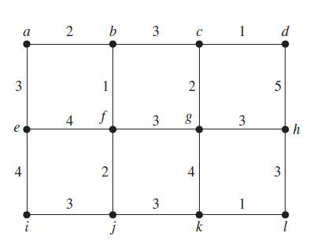
2. Construct the truth table for the following : (P ↔ Q) ↔ (PΛQ) V (⌐P V ⌐Q).
3. Prove by using CP rule : If A works hard then B or C will enjoy themselves. If B enjoys himself , then A will not work hard. If D enjoys himself , then C will not. Therefore if A works hard , D will not enjoy himself.
4. Find the PDNF and PCNF .
5. Consider the circuit (F2)

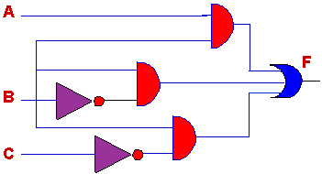

Determine the Boolean function implemented by this circuit. Complete the truth table for this circuit. How many minterms does it have? Draw a simpler circuit that implements this function. (8)

b) On the set $S=\left\{a, b, c\right\}$, consider the relation $R=\left\{\left(a,a\right), \left(b,b\right), \left(c,c\right),\left(a,b\right), \left(b,c\right), (c,a)\right\}$. Is the relation a partial order? (4)

16. Consider the following Hasse diagram (F2)

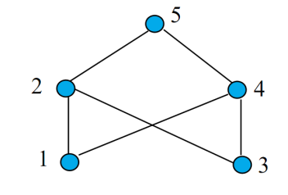

Is it a lattice? Justify your answer.

17. Use Chinese Remindar theorem to find a solution to each linear systems :

(a) x ≡ 1 mod 2; x ≡ 2 mod 3; x ≡ 3 mod 5;

(b) x ≡ 0 mod 2; x ≡ 0 mod 3; x ≡ 1 mod 5; x ≡ 6 mod 7.

**All the Best**